ANALYSTLAB AFRICA
Machine Learning Internship Programme — Week 2
Data Preprocessing Report
Customer Churn Prediction Project — Telco Customer Churn Dataset

1. Objective
This report documents the full preprocessing pipeline applied to the raw Telco Customer Churn dataset (7,043 rows, 21 columns) to transform it into a clean, fully numeric, machine-learning-ready dataset, with every decision justified. The corresponding executable pipeline is in week2_preprocessing.ipynb.

2. Data Quality Issues Identified
Issue | Description | Resolution
TotalCharges mistyped | Stored as text (object) instead of numeric; hides 11 missing values disguised as blank strings | Converted to numeric; blanks imputed with 0
Hidden missing values | The 11 blanks above are invisible to a standard .isna().sum() check because they are empty strings, not NaN | Explicitly detected via string inspection before relying on isna()
Logical pattern behind missing values | All 11 blank TotalCharges rows have tenure = 0 (brand-new customers, no charges accumulated yet) | Imputed as 0, consistent with business logic (not a random error)
Redundant categorical labels | 7 columns contain “No internet service” / “No phone service”, exactly duplicating information already in InternetService / PhoneService | Standardized to “No” to remove redundancy before encoding
Duplicate records | Checked for fully duplicated rows and duplicate customerID | None found — 0 duplicate rows, 0 duplicate IDs

3. Data Cleaning Decisions
- TotalCharges: replace blank strings with NaN, convert column to numeric (pd.to_numeric), then fill the resulting 11 missing values with 0.
- Duplicates: verified via df.duplicated() and customerID.duplicated() — none present, no rows removed.
- Standardization: replaced “No internet service” and “No phone service” with “No” across OnlineSecurity, OnlineBackup, DeviceProtection, TechSupport, StreamingTV, StreamingMovies, and MultipleLines.

4. Feature Engineering
Three new features were created, each tied to a specific business hypothesis about churn drivers:
Feature | Definition | Rationale
TenureGroup | tenure binned into 0-12, 13-24, 25-48, 49-72 months | Churn risk is concentrated in early tenure, not linear — confirmed: 47.4% churn in 0-12 months vs 9.5% in 49-72 months
NumServicesSubscribed | Count of active services (phone, internet, security, backup, protection, support, streaming) | More services subscribed suggests the customer is more “anchored” and less likely to churn
AvgChargePerService | MonthlyCharges divided by NumServicesSubscribed | Captures perceived value-for-money; high cost per service may signal dissatisfaction
customerID was removed as it is a unique identifier with no predictive value and risks overfitting if left in the feature set.

5. Feature Encoding
Technique | Columns | Justification
Label Encoding (0/1) | gender, Partner, Dependents, PhoneService, PaperlessBilling, Churn | Naturally binary — no order or magnitude is lost by mapping to 0/1
Ordinal Encoding | Contract (Month-to-month < One year < Two year), TenureGroup | These categories have a genuine natural order; One-Hot Encoding would discard that ordering information
One-Hot Encoding | MultipleLines, InternetService, OnlineSecurity, OnlineBackup, DeviceProtection, TechSupport, StreamingTV, StreamingMovies, PaymentMethod | Nominal categories with no inherent order; one-hot avoids implying a false ranking

6. Feature Scaling
StandardScaler (zero mean, unit variance) was applied to the five numeric columns — tenure, MonthlyCharges, TotalCharges, NumServicesSubscribed, AvgChargePerService — after outlier treatment. StandardScaler was chosen over MinMaxScaler because it is the more robust default for algorithms sensitive to feature scale, such as Logistic Regression, and it was applied after outlier capping (Section 7) so extreme values do not distort the mean/variance used for scaling.

7. Outlier Detection & Treatment
Outliers were checked using both the IQR rule (1.5×IQR beyond Q1/Q3) and the Z-score method (|z| > 3) on all numeric columns.
- tenure, MonthlyCharges, TotalCharges, NumServicesSubscribed: 0 outliers detected by either method — these are naturally bounded by real business limits (e.g. tenure between 0 and 72 months).
- AvgChargePerService: ~3.3% of rows (233 customers) flagged as outliers by both methods — customers paying comparatively much more per service.
Treatment: rather than deleting these 233 rows, they were capped (winsorized) to the IQR bounds. These are legitimate customers, not data-entry errors, so removing them would discard real signal; capping limits their leverage on the model while preserving the observation.

8. Feature Selection
Three complementary methods were used to assess which features contribute most to the churn prediction problem:
- Correlation with Churn: Contract (-0.40), tenure (-0.35), TenureGroup (-0.35), InternetService_Fiber optic (+0.31), PaymentMethod_Electronic check (+0.30), and the engineered AvgChargePerService (+0.30) are the strongest linear correlates.
- Variance Threshold (0.01): no columns fell below the threshold — no features were dropped on this basis.
- Random Forest importance: tenure, Contract, TotalCharges, MonthlyCharges and AvgChargePerService rank highest, cross-validating the correlation results and confirming that the engineered features carry genuine predictive signal rather than noise.
No features were removed at this stage; the analysis instead confirms which features are likely to matter most for model development in the following weeks.
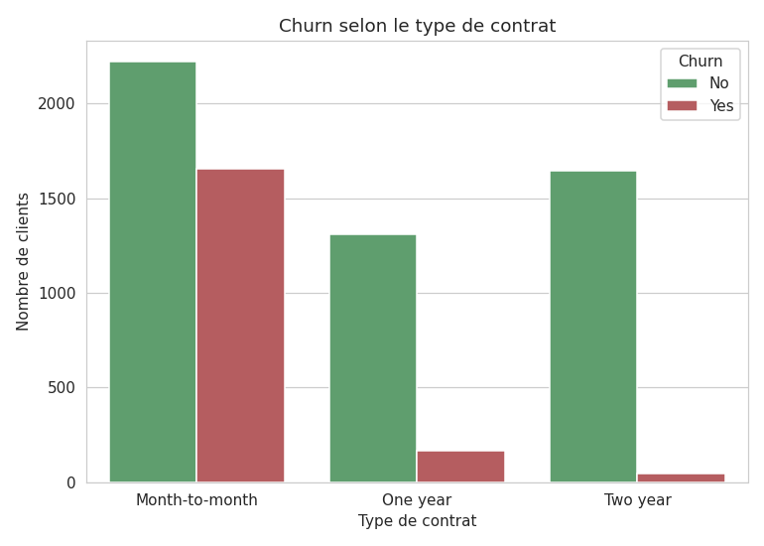
Figure 1. Churn rate is far higher for month-to-month contracts than for one- or two-year contracts, consistent with Contract being the top-ranked predictor.
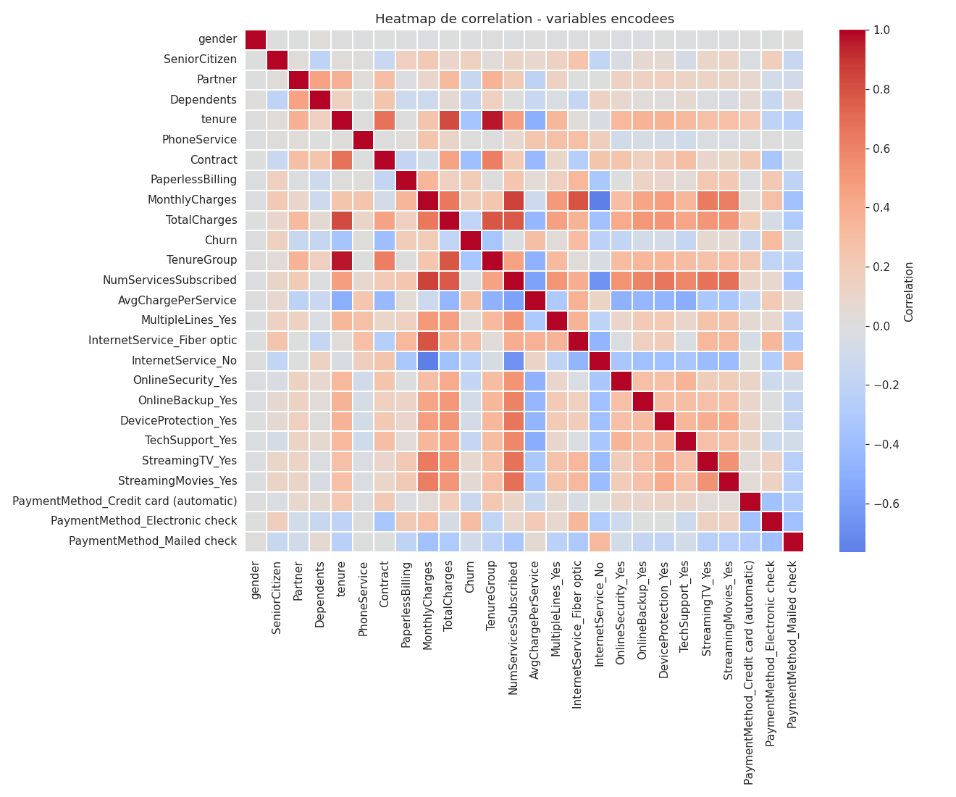
Figure 2. Correlation heatmap of the fully encoded feature set used for feature selection.

9. Final Dataset Summary
Property | Value
Rows | 7,043
Columns (final, encoded) | 26 (25 features + target)
Missing values | 0
Non-numeric columns remaining | 0
Duplicate rows | 0
Output file | telco_ml_ready.csv

10. Key Observations
- The most consequential data quality issue was silent: TotalCharges looked complete under a standard missing-value check purely because its missingness was encoded as blank text rather than NaN. This is a reminder to inspect dtypes before trusting isna().
- Tenure-related signal is very strong — both the raw tenure column and the engineered TenureGroup rank near the top of every feature-importance method, and churn rate drops from 47.4% to 9.5% across tenure groups.
- The engineered AvgChargePerService feature validated itself: it both required outlier treatment and ranked in the top 5 features by both correlation and Random Forest importance, suggesting it captures a distinct, useful signal beyond the raw billing columns.
- The dataset is now fully numeric, free of missing values, and encoded/scaled consistently — ready for model training in the next phase of the project.

